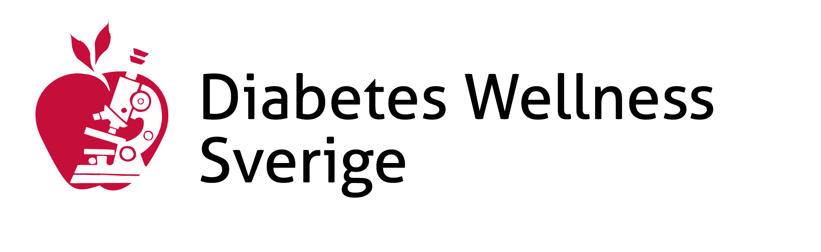

Application Procedure

Section (1): Scope

The Application Procedure is for:
• Grant applicants

Section (2): Types of Grant

There are currently two types of grant offered by the Diabetes Wellness Sverige (hereafter referred to as DWS)

The Innovation in Diabetes Research Grant (IDRG)
The IDRG is provides financial support forsmaller-scale, proof-of-concept type of projects from talented early-mid career researchers across Sweden..

- Maximum award value – 200 000 SEK
- Applications can be basic science or clinical research in any area of type 1 or type 2 diabetes including causes, complications, treatment or prevention
- Applicants should have no more than seven years of postdoctoral experience
- Applications are only considered from researchers working in Swedish institutions

The DWS Project Grants

The DWS Project Grants are designed to fund larger pieces of work and applications are invited from all interested researchers

- Maximum award - 1 million SEK per year
- Maximum duration of award - 2 years
- Applications can be basic science or clinical research in any area of type 1 or type 2 diabetes including causes, complications, treatment and prevention
- Applications will only be considered from researchers working in Swedish institutions

Section (3): Grant Submission

Stage 1: Call for applications and submission deadlines are advertised on the DWS website combined with invitations by emails to previous applicants and to relevant academic organisations.

Stage 2: Applications must be received by the DWS by the advertised deadline. No extenuating circumstances will be considered for late electronic submission.

Stage 3: One hard copy of the application signed by the Principal Investigator, all the co-applicants, the Head of Department where the research is to be conducted and the Head of the Finance for the relevant research institution must be received by the DWS office within one calendar month of the deadline

Section (4): Grant Post-Submission Process

IDRG and Project Grant

- All applications are reviewed and evaluated by members of the Research Advisory Board.

- The top scoring applications are further reviewed at the annual Research Advisory Board meeting and the successful applications are recommended to the Board of Trustees for their approval

- Successful and unsuccessful applicants are advised by letter or email within one calendar month after the trustees board decision date

Section (5): Review and Update of the Application Procedure

The Charity will endeavour to review the application procedure at regular intervals as needed, in consultation with its Board of Trustees.

Policy adopted on [01/05/2024]

